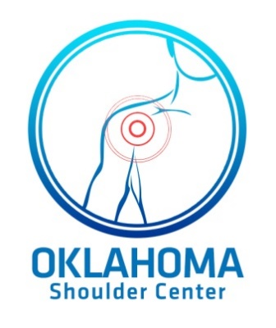

Oklahoma Shoulder Center PLLC

Betsy M. Nolan MD

725 NW 11th St

Oklahoma City, OK 73103

Ph: 405-278-8006

www.okshoulder.com

**Ulnar (Medial) Collateral Ligament Reconstruction**

**Post-Operative Protocol**

**Phase 0 and Precautions**

1. Check for clean and dry incisions
2. Graft sites: palmaris longus, gracilis and semi-t tendon
3. Educate patient on posterior splint and brace wear
4. Protect graft: **NO extreme Flexion, Extension, and/or Valgus**

**Phase 1 – immediate postoperative phase (0-3 weeks)**

Goals: Protect healing tissue, decrease pain/inflammation and retard muscle atrophy

* Postoperative week 1

1. Posterior splint at 90 degrees’ elbow flexion
2. Wrist AROM extension/flexion
3. Elbow compression dressing (2-3 days)
4. Exercises: Gripping, Wrist ROM, Shoulder Isometrics (No Shoulder ER), & Biceps Isometrics
5. Cryotherapy
6. May initiate from throwing with splint on (use truck and lower extremity components for overhead delivery with arm at side) – a.k.a. shoulder dumping
7. Knee ROM (with gracilisor semi-t Passive-to-active pain-free)

* Postoperative week 2

1. Application of functional brace 40 to 90 degrees
2. Initiate wrist isometrics
3. Initiate elbow flexion/extension isometrics
4. Continue all exercises listed above

* Postoperative week 3

1. Advance brace 15(20) to 110 degrees (gradually increase ROM, 5 degrees of extension/ 10 degrees of flexion per week)
2. Isometric ham set and SLR (pain-free)

**Phase 2 – Intermediate phase (4-8 weeks)**

Goals: Gradual increase in ROM, promote healing of repaired tissue, regain and improve muscular strength.

* Week 4

1. Functional brace set (10 to 120)
2. Begin light resistance exercises for am (1lb) wrist curls (extension, flexion, pronation/supination, and elbow flexion and extension)
3. Progress shoulder program, emphasize RTC strengthening (avoid ER until 6th post-op week)

* Week 6

1. May DC Brace
2. Progress elbow strengthening exercises
3. Initiate shoulder ER strengthening
4. Progress shoulder program
5. Progress LE strengthening (quad and ham)

Phase 3 – Advances strengthening phase (weeks 9-13)

Goals: Increase strength, power, and endurance, maintain full elbow ROM and gradually initiate sporting activites.

* Week 14

1. Initiate interval throwing program (or determined by physician)
2. Continue strengthening program
3. Emphasize on elbow and wrist strengthening and flexibility exercises

* Week 22-26

1. Return to competitive throwing (or determined by physician

**DC criteria: Full ROM, good to normal strength, and return to ADL’s**

Referenced from The Athlete’s Elbow by Andrews JR, Altchek DW